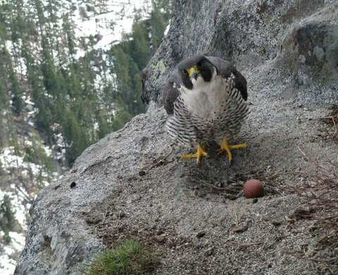OHIO STATE UNIVERSITY EXTENSION

Ohio Certified Volunteer Naturalist Program
Training Program Application
Name:

Mailing Address:

County where you reside:

Phone:

Email:

What are your reasons for wanting to become an Ohio Certified Volunteer Naturalist?

CFAES provides research and related educational programs to clientele on a nondiscriminatory basis. For more information: go.osu.edu/cfaesdiversity

Please explain why you feel you are a good candidate for the OCVN program:
Please tell us about any nature related similar programs you have participated in previously. Include approximate dates of your involvement.

Tell us about any park districts, nature centers, schools, or similar institutions where you are a volunteer or have recently provided volunteer services:
LOCATION | ACTIVITIES

OHIO STATE UNIVERSITY EXTENSION

The primary purpose of the OCVN program is to increase the knowledge and skills of local volunteers. Volunteer service in local parks, nature centers, etc. is an essential part of being an OCVN.

I understand that volunteer service is an essential part of being an OCVN and I intend to fulfill the requirements to maintain certification (40 hours during your first year and 20 hours annually thereafter). (please initial) NOTE: This can be done at the location(s) of your choice.

Indicate days of the week and time of day you are available to volunteer:
 | Morning | Afternoon | Evening
Sunday
Monday
Tuesday
Wednesday
Thursday
Friday
Saturday
Review the schedule of classes on the OCVN flyer. Please indicate any dates or times you will not be able to attend. Note that you may miss a maximum of two classes to become certified and you must work with the local OCVN coordinator to make up for any missed classes.

Dates I cannot attend class:
Many parks and nature centers where OCVN participants will be volunteering require a criminal background check before you can volunteer. Are you aware of anything in your history that might disqualify you from volunteering, including any misdemeanor or felony convictions?

Yes Please explain:

No
Please note: You will not be considered an OSU Extension Volunteer and will thus not be required to do a criminal background check for OSU Extension.

OHIO STATE UNIVERSITY EXTENSION

References:
List three non-family members who have knowledge of your skills, abilities and qualifications to become an OCVN. References should have worked with you on projects and activities and/or have direct experience with or knowledge of your qualifications. Please only provide names of individuals you are comfortable with us contacting:

Name | Phone | Email

The information I have provided on this application is accurate to the best of my Knowledge.
Signature
Date
Because of the limited class size, we recommend you submit your application as soon as possible. Training dates are listed on the flyer. Applications are accepted at all times of year for the upcoming class.

Send a hard copy of your completed and signed application to:

OSU Extension Mahoning County
490 S. Broad St, Canfield, OH 44406

OHIO STATE UNIVERSITY EXTENSION

